The Myth of Theseus – The Great Athenian Hero
Assignment: We are going to spend the next two days reading Theseus’ story on the website: http://mythagora.com/bios/theseus.html. As you read, please determine the four most important or interesting scenes of Theseus’ mythic journey. Please depict these four scenes on your own “Grecian Urn.”
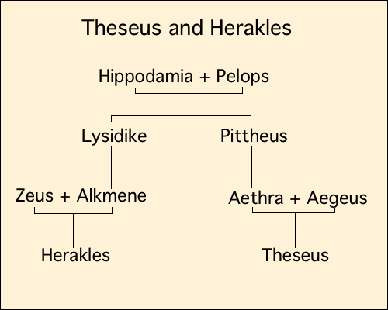
Theseus is considered the embodiment of the great Athenian hero; whereas, Herakles is considered the embodiment of the great Greek hero.
The Athenian Hero:  The Athenian hero is brave and fearless.  He possesses great bodily strength  He is also compassionate and caring  The Athenian hero valued thought and ideas over raw power and strength | Greek Hero:  A man, often of divine ancestry who is endowed with great courage and strength.  Performs amazing, superhuman feats  Involved in fantastic quests  Possess courage, loyalty, and fairness  However they do have faults:  Rage, jealousy, lack of wisdom (intelligence)

Historical Significance of the Grecian Urn:
In ancient times, urns were very common. They were used to store food, water, and wine. They held things like cosmetics, perfumes, and spices, and they were often used to transport things. The Greeks also decorated these urns with beautiful designs that would depict the stories of their culture. Remember, if most people were illiterate, how could stories be passed on to future generations? The best way to keep stories alive was through oral tradition, but the best way to remind people of their favorite stories on a daily basis was to depict these images on household items.

